1.Set up a new repository named username.github.io

2.Added an index.html file containing a home page with a brief introduction about myself.

Used basic HTML for structure and CSS for styling.

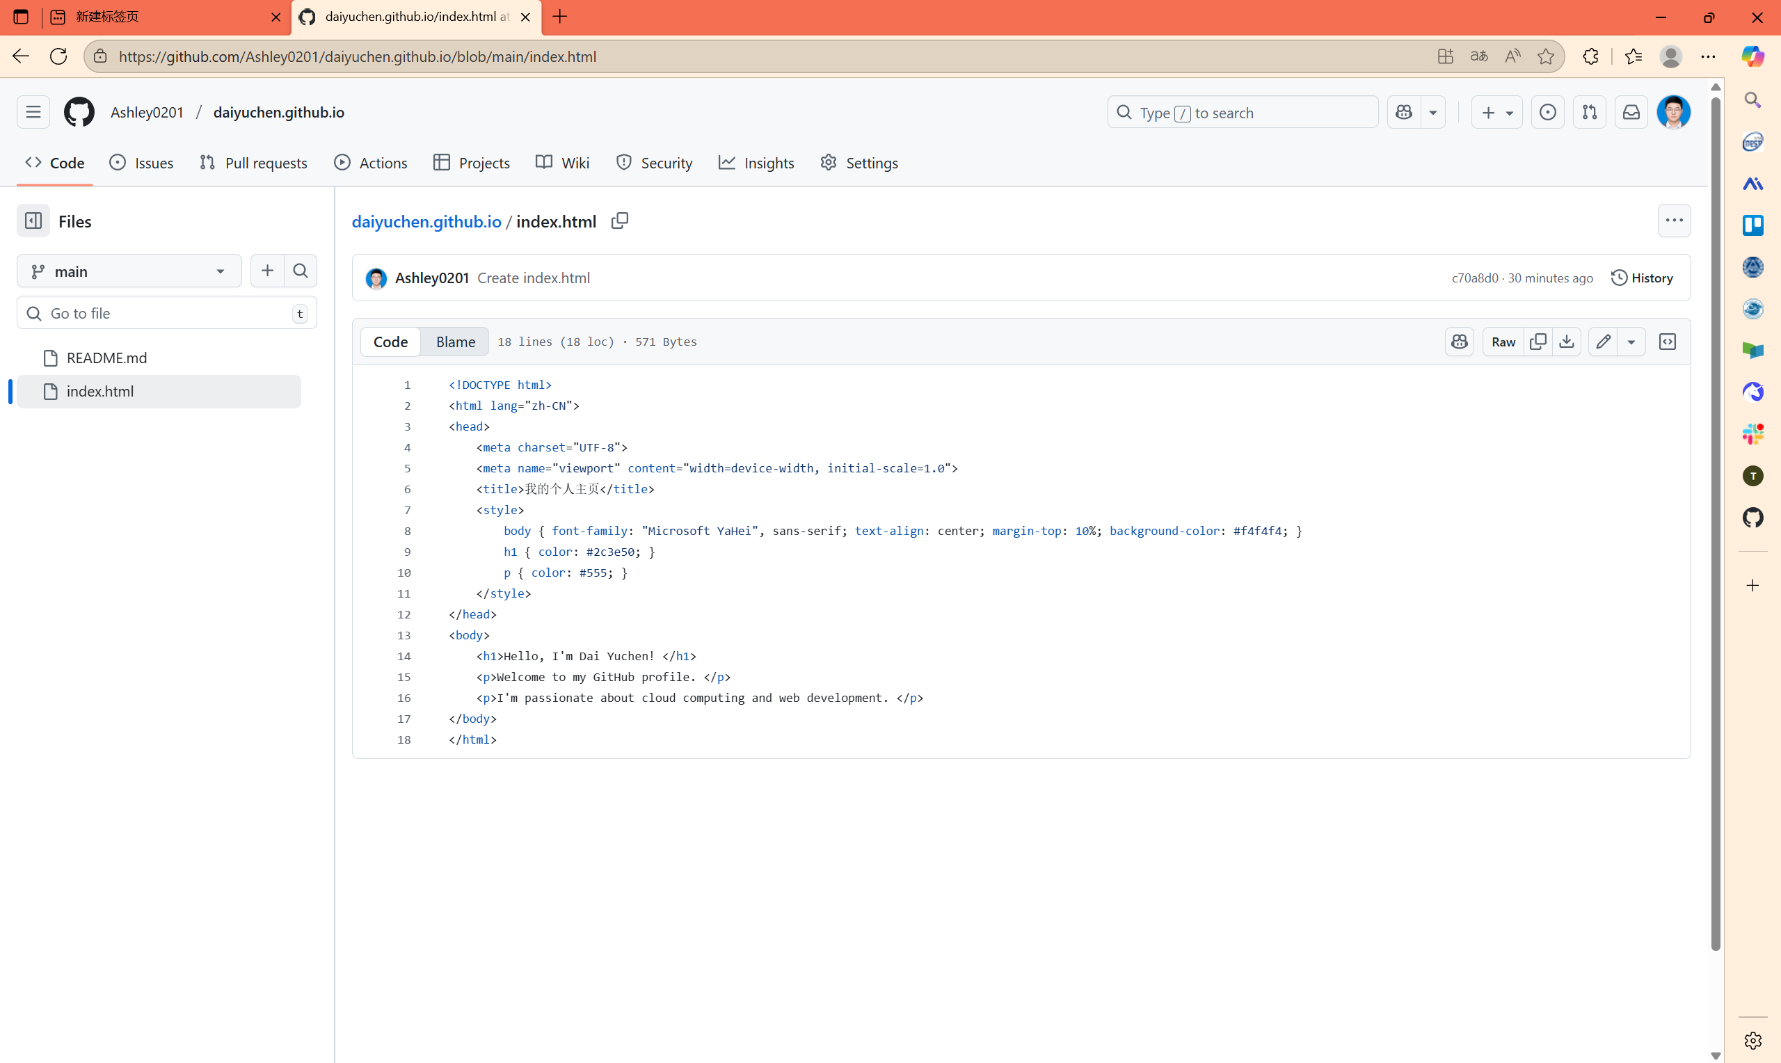

Optionally explored template designs and customization to make the site more visually appealing.

3.Deployment

Pushed the website files to the repository using Git.

Enabled GitHub Pages in the repository settings.

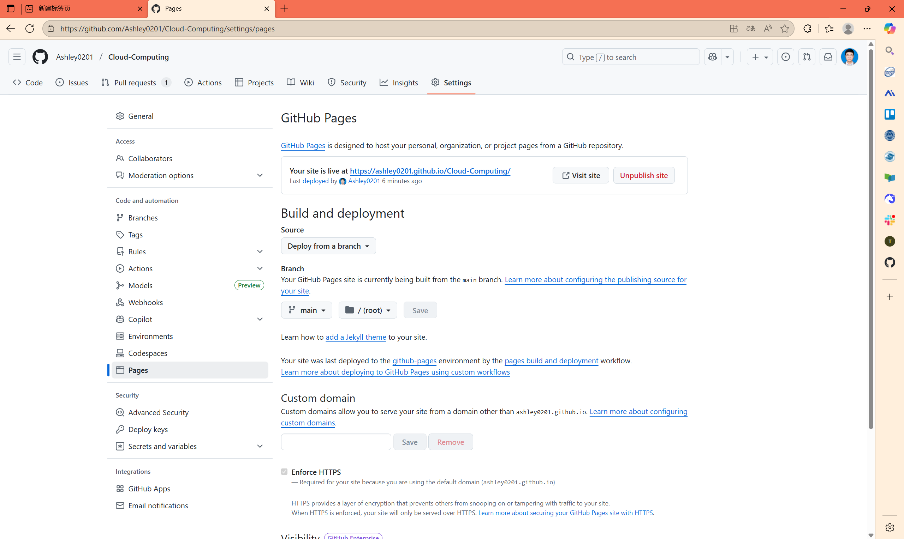

Verified that the website was live at [Ashley0201/daiyuchen.github.io](https://github.com/Ashley0201/daiyuchen.github.io)